SOURCE CODE:

#include<stdio.h>

#define max 5

int top=0, n=0, i;

int stack[5];

int pop();

int display();

int push(int);

int main()

{

int choice, x=1;

while(x)

{

printf(" 1: push\t\t 2: pop\t\t 3: display\t\t 4: exit\n");

printf("Enter your choice:\t");

scanf("%d", &choice);

switch(choice)

{

case 1:

printf("Enter the number to be pushed: ");

scanf("%d", &n);

push(n);

break;

case 2:

pop();

break;

case 3:

display();

break;

case 4:

x=0;

}

}

}

int push(var)

{

if(top>=max-1)

printf("The stack is full\n");

else

{

stack[top]=var;

top++;

}

}

int pop()

{

if(top==0)

printf("The stack is empty\n");

else

{

printf("The popped element is %d\t:", stack[top]);

stack[top]='\0';

top--;

printf("\n");

}

}

int display()

{

if(top==0)

printf("The stack is empty\n");

else

{

for(i=0; i<top; i++)

printf("%d ", stack[i]);

printf("\n");

}

}

OUTPUT:

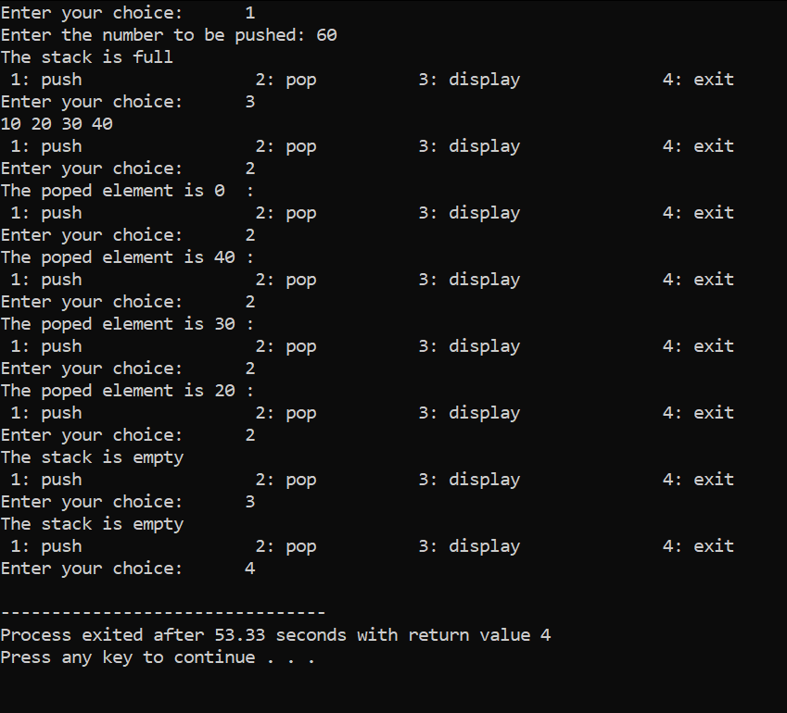

RESULT:

The C program has been successfully implemented to perform basic functions of stack.

SOURCE CODE:

#include<stdio.h>

#define max 5

int back=0, n=0, i, front=0;

int stack[5];

int pop();

int display();

int push(int);

int main()

{

int choice, x=1;

while(x)

{

printf(" 1: push\t\t 2: pop\t\t 3: display\t\t 4: exit\n");

printf("Enter your choice:\t");

scanf("%d", &choice);

switch(choice)

{

case 1:

printf("Enter the number to be pushed: ");

scanf("%d", &n);

push(n);

break;

case 2:

pop();

break;

case 3:

display();

break;

case 4:

x=0;

}

}

}

int push(var)

{

if(front<max)

{

stack[front]=var;

front++;

printf("%d is pushed\n", var);

}

else

printf("The stack is full\n");

}

int pop()

{

if(back<front)

{

printf("%d is popped\n", stack[back]);

back+=1;

}

else

printf("The stack is empty\n");

}

int display()

{

if(back<front)

{

for(i=back; i<front; i++)

printf("%d ", stack[i]);

printf("\n");

}

else

printf("The stack is empty\n");

}

OUTPUT:

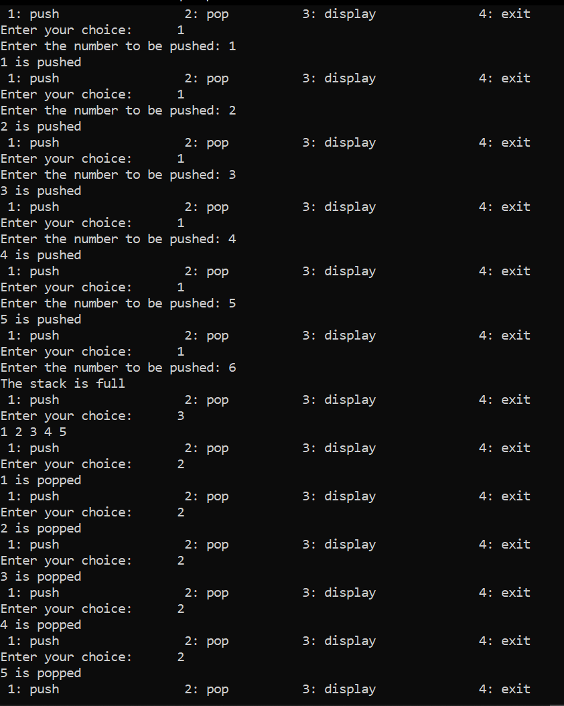

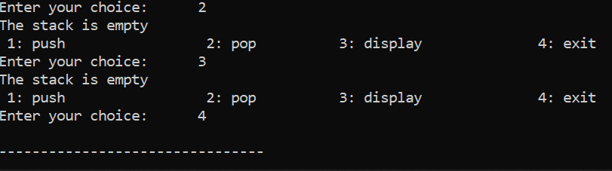

RESULT:

The C program has been successfully implemented to perform basic functions of queue.